PROBLEM –1
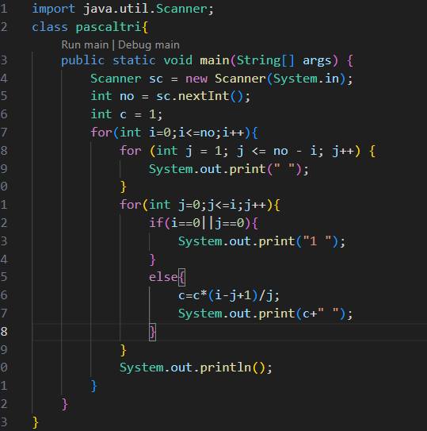
Output
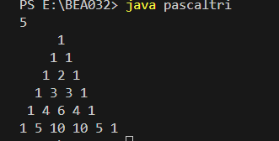
1)Collection are Similar to Array
2) But Dynamic
3)Can store more than one Element in a Single variable name in different Mode
4) Collection are Stored in “java.util.Scanner”;

